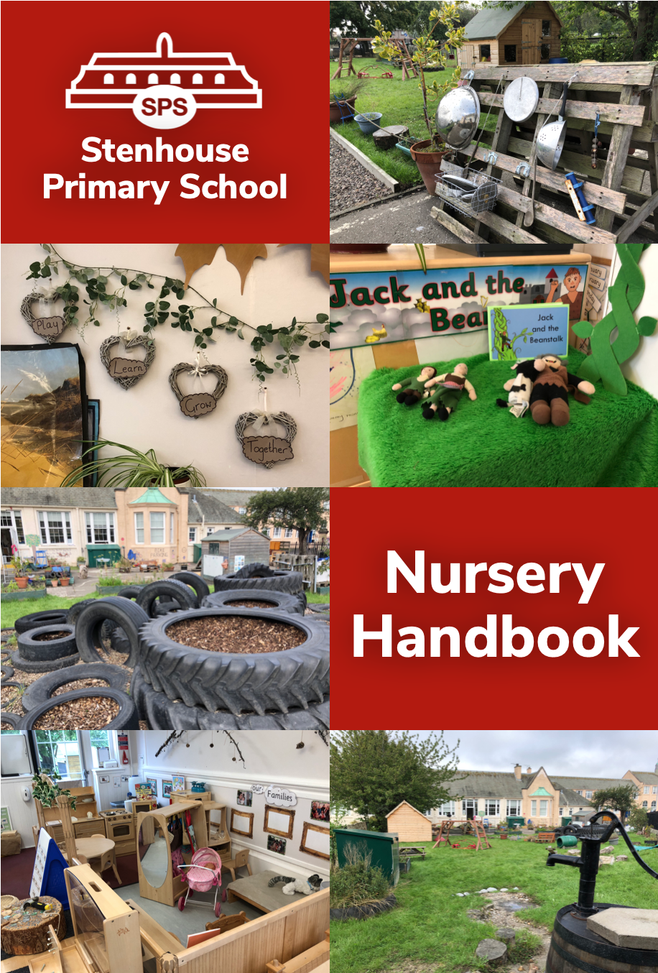

Updated – September 2024

Dear Parent or Carer,

The staff at Stenhouse Primary School Nursery Class are delighted to welcome your child and your family to our nursery community. We look forward to a long and happy association with you all. We hope your child will feel secure, confident and at home in our nursery environment and that the time they spend at nursery will be a positive and valuable learning experience.

We value the important role that you - as parents, carers and families - play in your child’s all-round development and learning and we aim to support this by offering a wide range of learning experiences which encourage your child to develop relationships with others, foster independence, develop their creativity, follow their curiosity, and learn through play.

The nursery is committed to working in partnership with parents, carers, and families. As well as striving to build children’s self-esteem and confidence, we place high importance on the safety and care of our children. All members of our nursery team follow Child Protection procedures, ensuring the safety and welfare of all children. If you wish to view these documents, please let a member of our team know, and we can provide you with a copy.

The help which you can offer the nursery greatly enhances the partnership between you and nursery staff and is of great benefit to our child. We therefore encourage you to feel that you are welcome in the nursery and assure you that staff will adopt a professional approach to any concerns you may have.

We look forward to working with you to make sure your child reaches their full potential.

Laura Monaghan Marie Renwick
Head Teacher Depute Head Teacher

Our Nursery Vision


Learn
Together
Grow
Play

Our Nursery Values
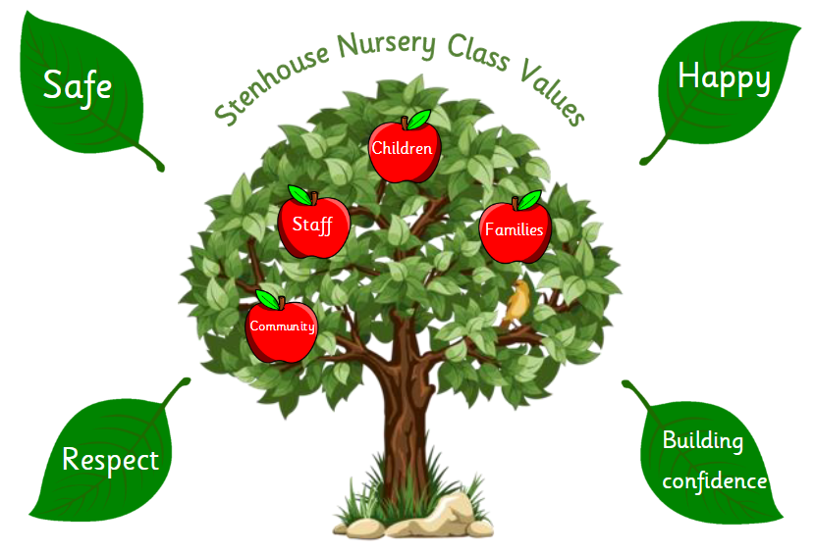


Our Nursery Aims

We make sure that every child knows they are important to us.
We value children’s play.
We care for the whole child, making sure they are happy, secure and safe.
We respect everyone’s similarities and differences.
We involve children and families in the decision making in the nursery.
We always try to do our best.

General Information

Our nursery class provides early learning and childcare for children aged three to five years old. We provide each child with their full annual entitlement of Early Learning and Childcare.

Stenhouse Nursery Class
Stenhouse Primary School
4 Saughton Mains Street
Edinburgh EH11 3HH

Telephone: 0131 443 1255

email: admin@stenhouse.edin.sch.uk

Session Times

Monday to Thursday Soft start 8.30 am – 9.00 am
Pick up 2.30 pm – 3.00 pm
Friday Soft start 8.30 am – 9.00 am
Pick up 12.00 pm – 12.30 pm

When your child begins to attend our full sessions, you may drop your child off any time during our soft start times, and collect them any time during our rolling pick up times.

It is important that children are collected on time at the end of each session. Children can become distressed if they are late being collected. Time is also set aside at the end of the day for staff discussion, training, cleaning processes, and preparation. If your child is not collected on time at the end of the session, they will be taken to the school office or a member of the school management team to await collection.

Settling In Period

New children will undertake a settling in period over a couple of weeks, and often tailored to the needs of the child, building up gradually to attending our full session times. Coming to Nursery may be the first experience your child has had of being away from their family and their home for an extended period of time. It is for this reason that children are introduced gradually and that you will be required to stay with your child on their first few days and possibly on subsequent days.

- Please do not arrive before your starting time on your child’s first few days – this allows our team to settle the other children, and prepare for your child’s arrival.
- Please arrive at the time agreed for collection – this has been given to provide the best possible support for your child.
- During the first few weeks your child’s individual needs will be discussed and drop-off and pick-up times will be agreed daily between you and a member of our nursery team.
Our Nursery Team

Our nursery team is made up of a range of specially trained and qualified staff. The day-to-day running of the nursery is led by our Early Years Officer, supported by our DHT. The nursery team as a whole work together and any member of staff will be happy to help you.

As a team, we work closely with other professionals from education and health, such as Health Visitors, Educational Psychologists, Speech and Language Therapists, Occupational Therapists and Specialist Teachers. We also regularly welcome Modern Apprentices, HNC Early Education and Childcare Students, Speech Therapy Students and work experience pupils from secondary schools to our team.

Head Teacher Mrs Laura Monaghan
Depute Head Teacher Mrs Marie Renwick
Principal Teacher Mrs Anna Hind
Acting Principal Teacher Miss Emma Collier
Early Years Officer Miss Effie Mackay
Early Years Practitioner Mrs Vicky Thomson
Early Years Practitioner Mrs Leanne Coppins
Early Years Practitioner Miss Kirsty Lamb
Early Years Practitioner Miss Kerry-Ann Taylor
Early Years Practitioner Ms Rachel Murdoch
Early Years Assistant Miss Kelly Glancy
Modern Apprentice Miss B Dunn

Most of your queries at this stage of your child’s education are best answered through informal discussion with members of our nursery team, who will be pleased to talk to you on any subject concerning your child. However, this booklet is designed to be helpful to you by answering some of the questions you may have about our Nursery.

Your Contact Information

When your child starts at nursery, you are required to complete forms including providing accurate contact information. You will also be asked to review this form, to check that the details are up-to-date during the year. If any of your details – such as your address, telephone numbers, or emergency contact information – change, please make sure you inform the nursery team as soon as possible.

If an emergency arises concerning your child and you or your nominated emergency contact cannot be contacted, a member of the Management Team will take such decisions as necessary in the circumstances.

Taking your Child to and from Nursery

Every child must be brought to and collected from the Nursery by a person over the age of 16. You will nominate a small number of adults who will be allowed to collect and drop off your child. Please make sure you inform a member of our nursery team if someone who is not on this list will be picking up your child from nursery for any reason. If you do not inform us that someone different will be collecting your child, we will not be able to release your child.

Attendance and Absence

If your child is ever unwell, please contact the school (0131 443 1255) to make us aware of the reason for their absence. You can leave a message or you can ask to be transferred to the nursery to discuss with a member of the team.

Children who have had diarrhoea or vomiting must not return to nursery until 48 hours after their last bout.

Please inform the nursery team as soon as possible if your child has any illness or condition that may be infectious, such as chickenpox or measles. This will enable the team to take the appropriate steps to reduce the risk of any infections spreading.

In the event of your child becoming unwell during the nursery session you will be contacted by us and asked to collect them.

Playing and exploring the outdoors is a very important part of our children’s learning in nursery. We cannot keep children indoors during nursery sessions. If you feel your child is not well enough to play outdoors, please keep them at home.

There is a waiting list for nursery places therefore it is important that your child makes full use of the place by attending regularly. If problems with regular attendance are experienced, please discuss this with a member of our nursery team.

It is important that nursery team members are made aware of any family problem which is likely to upset your child. We will be able to offer the appropriate support and comfort your child needs if you let us know.

Family Holidays

Your child's nursery experience is to be valued. It is excellent preparation for school and your child’s development is supported through regular attendance. Therefore, we ask that you consider any disruption to your child's routine and progress that may arise from absence during the nursery and school session. If you do decide to remove your child from nursery for a period of time to go on holiday, please inform a member of the nursery team in advance.

Clothing

Comfortable clothes for outdoor as well as indoor play are the order of the day. Aprons are provided for certain types of activities but accidents do happen, therefore do not dress your child in clothes which may be special. It is much easier for a child to be independent at the toilet if difficult buckles, belts and tight jeans are avoided. Slip on shoes are ideal and your child should be encouraged to try to put them on the correct feet. Flip-flops, shoes with sling-backs, or open toe sandals should not be worn as these are not safe. Hoop earrings are not permitted for reasons of safety.

Encourage your child to put on their own coat. They may find this tricky at first, but the more they practise the better they will get. Encourage them to keep giving things a go and not to give up! Our nursery team will also be encouraging them to develop these independence skills at nursery.

All items of clothing including footwear such as welly boots should be clearly marked with your child’s name.

Please supply the nursery with at least one full change of clothes including underwear, marked with your child’s name. These will be kept in our nursery red bags on your child’s peg and used as a change of clothes if needed.

Your child will be issued with a waterproof jacket and a pair of waterproof trousers to use at nursery. Please make sure you bring in a pair of wellies for your child to wear outdoors.

Toys

We have lots of lovely toys in the Nursery which the children enjoy playing with and which encourage children to explore, be creative and learn new things. If your child brings home a piece of jigsaw or any other item of nursery equipment by mistake, please return it as soon as possible.

Children are encouraged not to bring their own toys to the Nursery. Children can become easily upset if their own toys get lost, broken or played with by other children.

Children’s Work

Children can work very hard at nursery and produce lovely works of art of which they are extremely proud. Your child may bring home some of their creations, and we encourage you to talk to your child about what they have made. These can be found in the green pockets in the cloakroom; we encourage you to check this daily.

Lunch and Snacks

When your child attends for a full day Monday to Thursday, they will be offered a morning snack and a lunch. They will also have the option of an afternoon fruit snack. Drinks are available throughout the session. On Fridays, as the children leave at 12.30 pm, they will be offered a more substantial morning snack during the session and they will be given a packed lunch home with them at pick-up.

Our lunch and snack menu is specially designed to be balanced, healthy, and to encourage children to try new foods. Our hot lunches are prepared at Longstone Resource Centre catering kitchen and delivered to the nursery where the children eat them together.

We aim to provide a ‘family-style’ dining experience for children at lunch times, with children sitting together around small tables, enjoying their food, and talking together. We will be helping children develop their skills using knives and forks, but we ask that you also support and encourage your child at home to use cutlery at meal times. Like most skills for young children, it takes a lot of practice for them to master it, so don’t be discouraged if they find this tricky at first!

The school has a policy for health promotion and healthy eating and in the nursery we encourage this by offering fruit, vegetables and a savoury snack at snack times. We follow the national guidelines “Setting the Table”. This document helps us to ensure that we serve healthy, balanced snacks. If you would like to know more you can find the document here: http://www.healthscotland.com/documents/30341.aspx

We celebrate each child’s birthday in nursery. They choose some friends to bake a simple cake which is shared with their friends. We ask that parents do not send any further sweet treats in to support our allergy procedures and our healthy eating policies.

Realising the Ambition: Being Me

As a team, we engage with Realising the Ambition: Being Me document to ensure our approach is child-centred and meets the needs of all our children. A copy of this document can be found here: https://education.gov.scot/improvement/learning-resources/realising-the-ambition/

Teaching and Learning in Nursery

Curriculum for Excellence is a curriculum for all children aged 3 to 18 years. It is a coherent, flexible and enriched curriculum for learners. The aims of Curriculum for Excellence are that every child and young person should know they are valued and will be supported to become a successful learner, an effective contributor, a confident individual and a responsible citizen. The Curriculum is structured around all the experiences that are planned as part of learning and teaching.

The eight key areas are:
- Literacy
- Numeracy and Mathematics
- Health and Wellbeing
- Sciences
- Social Studies
- Technologies
- Expressive Arts
- Religious and Moral Educations

It is widely recognised that nursery-age children learn best in a child-centred play environment. Through play, children explore, discover and learn many new and exciting facts about their world. The children choose where to play - their natural curiosity motivating them to participate in the opportunities offered. As children play in their chosen areas, staff support and encourage them to make connections between past and new experiences.

There are also opportunities for children to take part in more directed activities, such as group time and story time where children develop skills in listening, talking and turn taking. The children are encouraged to have a significant role in developing their learning environment. Through careful observation, discussion and reflection the children are involved in the planning and decision making of the nursery. This safe and friendly atmosphere promotes confidence and self-esteem and lays the groundwork for a smooth transition from nursery to primary.

Learning Journals

Your child’s online learning journal is an online profile of your child’s learning and achievements at nursery and at home. It brings parents, carers and nursery together to support your child’s development and progress. Parents are given login details to access their child’s learning journal on an internet-enabled device at any time. You can also add comments and posts to your child’s journal from home.

What can parents and carers do to help?
Value and praise your child’s achievements. Take time to look at your child’s learning journal posts with them at home. Add your own photos and comments, to celebrate their interests and successes from home.

Getting Involved

Research shows, that parental involvement in children’s education from an early age has a significant positive impact on educational achievement. We value your contribution and recognise that this can take many forms.

Parent Council / PTA

We have an active Parent Council which provides very good support to the school and nursery. The committee helps promote the educational activities of the school and raises much needed funds for our school and nursery through a variety of methods and events. More parent helpers are always greatly appreciated.

Watch out for Parent Council newsletters or contact the school for further information. You can also search for Stenhouse Primary School Parent Council on Facebook or @ptastenhouse on Twitter.

Twitter

Please follow the nursery on Twitter for regular updates and photographs. Our page is @nurserysps.

Key Worker Check-In
You are invited to a meeting/phone call twice a year with your child’s keyworker. We will share information about these appointments nearer the time. You can, of course, chat to members of the nursery team during the year about your child – we are happy to listen and support. It is best to catch us when you are dropping off your child at the start of the day.

Family Learning

You will be regularly invited into the nursery for a variety of events such as Family Singing, Stay and Play, Number Rhymes sessions, Peep sessions and more. We will share more information about these opportunities once your child has settled in.

Transition Report

A Transition Report is provided to parents and carers in June for children who are due to begin primary school in August. These reports are also shared with their new class teachers to help ease the transition into Primary One.

Appointments & Calls

If you have any concerns about your child’s progress you can make an appointment to discuss this with Mrs Renwick or a member of the nursery team.

How we keep you informed

- Through informal conversations with you
- Nursery & School Newsletters
- Letters
- By email (via Online Learning Journals)

Health & Well-being

Medicines

If your child requires regular medication you need to complete a medical consent form before we can administer any medicines during the nursery session. In most cases a child who is in need of medicines to treat a temporary illness is best kept at home. Please speak to a member of staff at nursery about our medication policy.

ChildSmile Tooth Brushing

The establishment of daily supervised tooth brushing programmes in nursery is central to the Scottish Government’s oral health initiatives for children. ChildSmile is coordinated by the NHS and provides all the necessary equipment. A ChildSmile Tooth Brushing opt-out form will be sent home with your child once they have started nursery. The dental team visit nursery regularly to apply Fluoride Varnish and information will be shared with you about this nearer the time.

Getting it Right for Every Child

At Stenhouse we aim to ‘Get it Right for Every Child’. This means we work with people from key support agencies including health, social work, psychological services, education and, most importantly, the parents, carers, and child to coordinate support for children in order to best meet their needs.

Child Protection Guidelines

The nursery and school have child protection procedures in place and all staff undertake regular child protection training. Members of our team must follow the appropriate procedures if they ever have any concern about a child’s safety. If you wish to know more about these procedures, please ask a member of the nursery team.
Child Protection Coordinator - Marie Renwick DHT
ASN and EAL Coordinator - Marie Renwick DHT
If you ever have a concern about the safety or welfare of any child, you can call Social Care Direct on 0131 200 2324 to report it. In the evening and at weekends or public holidays, you can call Emergency Social Work, free of charge from a landline on 0800 731 6969. Your mobile phone provider may charge for 0800 calls.

Supporting Children’s Self Regulation Policy

Stenhouse Nursery Class provides an environment that encourages every child to display a positive attitude to their learning and behaviour, both in Nursery and the wider community. This is supported through recognition and lots of praise. This encouragement permeates all nursery activities. Individual needs of children will be met through communication with parents and carers. Our Supporting Children’s Self Regulation Policy is available to read in our Policy and Procedures Folder or on request.

ENROLMENT

Enrolment To Nursery

Enrolment into Nursery is governed by the guidelines laid down by City of Edinburgh Council. The minimum age of entry to the Nursery is three years old, but you may place your child’s name on the waiting list from the time they turn two years old. You will be contacted by the school when a place for your child is available.

Enrolment To Full Time Education

City of Edinburgh Council advertises in the local press in November each year, requesting parents of children who are due to turn four years old on or before 29 February the following year, to enroll their child for primary school.

Stenhouse Primary will advertise their enrolment arrangements and requirements for the city-wide enrolment week. Please look out for this date in early November. Notices will be displayed on the nursery noticeboard, and letters will be distributed to parents and carers.

If you do not live within our school catchment area, you need to make a special request to enroll your child for Primary One at Stenhouse Primary. You must enroll at your catchment school first and then complete an ‘Out-of-catchment request form’ stating your preference for your child to attend Stenhouse Primary. This is sent to the City of Edinburgh Council’s Education Department for consideration.

If you live within the school catchment area and wish your child to go to a school other than Stenhouse, you must still complete an admission form for Stenhouse. A space will then be kept by the school until a decision is made by the authority about your out-of-catchment request. If you have any questions about this process, please speak to a member of the nursery team who will be happy to advise.

If you have any worries or concerns about your child starting P1 please talk to a member of the nursery team. You may have the option to defer your child’s start date if their birthday falls between mid-August and end of February.

The Care Inspectorate

Like all care providers we receive regular inspections from the Care Inspectorate. A copy of our most recent report can be viewed by searching for ‘Stenhouse Primary School Nursery’ on the Care Inspectorate website: www.careinspectorate.com

Care Inspectorate Quality Framework

The main document we use to support our work in nursery is the Quality Framework. You can find a copy of this document here: Quality framework for early learning and childcare 2022 - final.pdf (careinspectorate.com)

Education Scotland

Like all nurseries in Scotland, we are also inspected by Education Scotland. This inspection normally takes place when the whole school is inspected. A copy of our school’s most recent inspection report is available online on the Education Scotland website: www.education.gov.scot/education-scotland/inspection-reports/

How to make a complaint

We want your child’s time at nursery to be a happy one. However, if you have a complaint or concern at any time, please share it with us. You can:

1. Speak to a member of our Nursery Team
If you have a concern or a complaint you wish to raise, please speak with a member of the Nursery Team in the first instance. Your comments and observations are taken seriously and can help us improve our procedures and practice. We endeavour to:
- deal with any issue quickly.
- let you know what is happening.
- check that you are satisfied with what we do.

2. Contact the DHT or Head Teacher
If you are not satisfied that your complaint has been resolved properly - or if you would prefer to speak to the Nursery’s line manager in the first instance - please contact our DHT, Mrs Renwick, or our Head Teacher, Mrs Monaghan. You may contact them via the school office, by calling 0131 443 1255 or by emailing admin@stenhouse.edin.sch.uk and marking the email for the DHT’s or Head Teacher’s attention.

3. Contact City of Edinburgh Council
Our nursery class is part of Stenhouse Primary School and run by City of Edinburgh Council. If you wish to complain directly to the council, you may contact the relevant department by emailing cf.complaints@edinburgh.gov.uk or calling 0131 469 3233.

4. Contact the Care Inspectorate
All care services, including nurseries, are monitored and inspected by the Care Inspectorate. If you wish to make your complaint to the Care Inspectorate you may contact them:
- via their website: www.careinspectorate.com
- by calling 0345 600 9527
- by emailing concerns@careinspectorate.gov.uk, or
- by post to: Care Inspectorate, 3 C&D South, Victoria Quay, Edinburgh EH6 6QQ

